|  |  |
| --- | --- |
| ***Zomato Sales Analysis***  20-11-2025 | *Newton School*    ***Chaitanya D. Vakte*** |

* Analyze and evaluate the data and come up with dynamic strategies to open new restaurant in various countries.

Objective Questions:

Note: All the question asked in module is presented in the form of answer and approach if needed.

**Q1. What is the total no. of tables present in the data?**

* There are two (2) tables provided in the given excel workbook first table in excel sheet raw data contains the details of restaurants, second one is country description which contains a table which has details regarding country and their country code.

**Q2. What is the total no. of attributes present in the data?**

* There are 20 columns in table which is in provided data sheet and 2 columns in table which is in country description sheet.

**Approach:** Here I used =COUNTA function of Excel to count the columns present in sheet

**Q3. How many categorical columns are there in the data?**

Categorical Columns are the columns that contain data that can be grouped into categories or fragments. There are 12 categorical columns in the table which is in the raw data they are, **RestaurantName, Country, City, Address, Locality, LocalityVerbose, Cuisines, Currency, Has table booking, Has online delivery, Is delivering now, Switch to order menu.**

* **Approach:** I counted categorical columns manually.

**Q4. The data consists of some inconsistent and missing values so ensure that the data used for further analysis is cleaned.**

We used to find and replace function to fill the blank cells in the raw data sheet

* + Handling the missing values in the "Cuisines" column.
  + Converting the "Datekey_Opening" column to a proper date format.

**Approach:**

**Missing Values**:

The "Cuisines" column is now filled with "Unknown" where data was missing.

Formula we use here **=IF(ISBLANK(K2), "Unknown", K2)**

**Date Conversion**:

The "Datekey_Opening" column has been successfully converted to a datetime format.

Formula we use **=SUBSTITUTE(U2,"_","/")**

### **Key Findings:**

1. **Missing Values**:
   * The "Cuisines" column has a few missing entries.
2. **Data Types**:
   * The "Datekey_Opening" column is stored as a string (object) and may need conversion to a date format.



Q4) Reference Chart

**Q5. Using the Lookup functions, fill up the countries in the original data using the country code**.

* **Approach:** I have created a new column with name Country Lookup to CountryCode and used a VLOOKUP Function **(=VLOOKUP(C2,'country description'!$A$1:$B$16,2) )**. I got the value for country and using fill handle filled column

|  |  |  |  |
| --- | --- | --- | --- |
| **CountryCode** | **Country** | **City** | **Address** |
| 1 | India | New Delhi | 13/288 , 14 Block Gurudwra, Geeta Colony, New Delhi |
| 1 | India | New Delhi | 726/2, Jheel Khuranja, Geeta Colony, New Delhi |
| 1 | India | New Delhi | C-222, Lajpat Nagar 1, New Delhi |
| 1 | India | New Delhi | Gali 7, Mahipalpur, New Delhi |
| 1 | India | New Delhi | Main Vasant Kunj Road, Mahipalpur, New Delhi |
| 1 | India | New Delhi | Shop 264, Near Hakikat Nagar, Mukherjee Nagar, New Delhi |

Q5. Reference Drawing

Q6. **Create a table to represent the number of restaurants opened in each country.**

* **Approach:** To solve this question we created the pivot table in new sheet added country column to in and made count of restaurant opened in respective country.

|  |  |
| --- | --- |
| **Row Labels** | **Count of RestaurantID** |
| Australia | 24 |
| Brazil | 60 |
| Canada | 4 |
| India | 8652 |
| Indonesia | 21 |
| New Zealand | 40 |
| Philippines | 22 |
| Qatar | 20 |
| Singapore | 20 |
| South Africa | 60 |
| Sri Lanka | 20 |
| Turkey | 34 |
| United Arab Emirates | 60 |
| United Kingdom | 80 |
| United States of America | 434 |
| **Grand Total** | **9551** |

**Q6. Refereance Table**

**Q7. Also, the management wants to look at the number of restaurants opened each year, so provide them with something here.**

* **Approach:**

Here we created new column in Raw Data giving us years from Datakey_opening and then adding the pivot table where row labels contain the year from Datekey_opening and count of restaurant id as value.

|  |  |
| --- | --- |
| **Row Labels** | **Count of RestaurantID** |
| 2010 | 1080 |
| 2011 | 1098 |
| 2012 | 1022 |
| 2013 | 1061 |
| 2014 | 1051 |
| 2015 | 1024 |
| 2016 | 1027 |
| 2017 | 1086 |
| 2018 | 1102 |
| **Grand Total** | **9551** |

**Q7. Referance Table**

**Q8. What is the total number of restaurants in India in the price range of 4?**

* + **Approach:**

I have created a new Pivot table with price_range as rows and count of RestaurantID as values and added a slicer for Country and filtered the data for India, from this table we can see that there are **388 restaurants** in India in price range of 4.

|  |  |  |  |
| --- | --- | --- | --- |
|  | |  | |
| Country | | India | |
|  | |  | |
| **Row Labels** | | **Count of RestaurantID** | |
| 4 | | 388 | |
| **Grand Total** | | **388** | |
|  | |  | |

**Q8. Referance Table**

**Q9. What is the average number of voters for the restaurants in each country according to the data?**

* **Approach:**

I created a pivot table where I took country in columns and average of votes in right side getting average number of voters for restaurants in each country.

|  |  |
| --- | --- |
| **Row Labels** | **Average of Votes** |
| Australia | 111.4166667 |
| Brazil | 19.61666667 |
| Canada | 103 |
| India | 137.212552 |
| Indonesia | 772.0952381 |
| New Zealand | 243.025 |
| Philippines | 407.4090909 |
| Qatar | 163.8 |
| Singapore | 31.9 |
| South Africa | 315.1666667 |
| Sri Lanka | 146.45 |
| Turkey | 431.4705882 |
| United Arab Emirates | 493.5166667 |
| United Kingdom | 205.4875 |
| United States of America | 428.2211982 |
| **Grand Total** | **156.9097477** |

**Q9. Referance Table**

**Q10. Calculate the average rating for all the restaurants that have price_range < 4 and provide online delivery. Use only the “IF” function, Logical Operators, and Aggregation functions to solve this problem**

* **Approach:** Here I have used the formula: “**=AVERAGE(IF(('Raw Data'!R2:R9552<4)*('Raw Data'!O2:O9552="Yes"),'Raw Data'!U2:U9552))”**to the average rating, I got average rating as **3.27381151.** Other approach for the same result is **=AVERAGEIFS(S2:S9552,M2:M9552,"Yes",P2:P9552,"<4")**

**Q11. Using Conditional formatting highlight the rows of restaurants that are located in the countries or cities that you’ve suggested to the management for opening new restaurants.**

* **Approach**:

Analyze the number of existing restaurants in each country and city to identify areas with lower competition. the data analysis reveals a clear positive correlation between offering online delivery and table booking services and higher customer ratings. Restaurants that incorporate both of these features tend to receive significantly better ratings compared to those that do not.

|  |
| --- |
| **Indonesia** |
| Jakarta |
| Tangerang |
| **New Zealand** |
| Auckland |
| Wellington City |
| **Philippines** |
| Pasay City |
| Taguig City |
| **Turkey** |
| Ankara |
| ÛÁstanbul |
| **United Arab Emirates** |
| Abu Dhabi |
| Dubai |

**Q11 Referance Table.**



(Note: Apply the filter of the given countries to get the selected countries Indonesia, New Zealand, Philippines, Turkey, UAE.)

**Q12. Create a new customized price column that consists of the abbreviation/symbol of the currency along with the Average_cost_for_two value.**

* **Approach:** I have used the “Trim” Function along with ”MID” and “FIND” function and created the new column named Average_cost_for_two_edited.

**=TRIM(MID(L2,FIND("(",L2)+1,FIND(")",L2)-FIND("(",L2)-1))&S2**

**Q13.How can you create an array formula in Excel or Google Sheets to count the number of restaurants listed that do not offer online delivery, are in the lowest price range, and have an average cost for two people less than or equal to 250 Indian Rupees?**

* **Approach:** Here using the array formula we get the number of 1694 by applying the condition of restaurants that don’t have online delivery and are in lowest price range, to get the lowest price range we used min option to get the min of price range column after that we used last condition of average cost for two people which should be less than or equal to 250. The formula used in excel is as follow

**=SUM(IF((N2:N9552="No")*(Q2:Q9552=MIN(Q2:Q9552))*(S2:S9552<=250),1,0))**



Subjective Questions:

**1) Suggest a few countries where the team can open newer restaurants with lesser competition. Which visualization/technique will you use here to justify the suggestions?**

* Indonesia
* New Zealand
* Philipines
* Turkey
* UAE

**Approach:-** Here we analyzed the number of restaurant in country and the number of the rating provided by the customers and by evaluating the average cost for two for each country we can build the positive correlation of all the terms and we can find the best option available with us to open a restaurant.

* **Data filtering:-**

Using the pivot table and considering the average_rating and focusing on the specific countries we get to know the market status in the country and forge the success status of restaurants in specific country.

By considering the average cost for tow we can predict the cost expenditure nature of people and analyze the current market condition for investment.

**Visualization Techniques:**

* **Line Chart**: To visualize the number of restaurants per country. This will help in identifying countries with fewer restaurants.

|  |  |
| --- | --- |
| **Row Labels** | **Average of Rating** |
| Australia | 3.7 |
| Brazil | 3.8 |
| Canada | 3.6 |
| India | 2.8 |
| Indonesia | 4.3 |
| New Zealand | 4.3 |
| Philippines | 4.5 |
| Qatar | 4.1 |
| Singapore | 3.6 |
| South Africa | 4.2 |
| Sri Lanka | 3.9 |
| Turkey | 4.3 |
| United Arab Emirates | 4.2 |
| United Kingdom | 4.1 |
| United States of America | 4.0 |
| **Grand Total** | **2.9** |

**Q2. Come up with the names of States and cities in the suggested countries suitable for opening restaurants.**

**1.Indonesia:**

* + Jakarta
  + Tengrang

**2.New Zeland:**

* Auckland
* Wellington City

**3. Phillipines:**

* Pasaya City
* Taguig City

**4.Turkey:**

* Ankara
* ÛÁstanbul

**5.UAE:**

* Abu Dhabi
* Dubai

**Approach:** Here we first focused of some of the countries with the help of pivot table and then filtered the data by calculating the average ratings of existing restaurants. It gave us the clear cut idea of the need of the market how will the restaurant perform.

**Key Insights:**

1. Selected cities from Indonesia, New Zealand, Phillipines, Turkey, UAE have huge population base with actively money spending peoples making this cities an ideal option for opening the restaurant.
2. The cities selected here are one of the major tourist destinations which automatically increases the need of good restaurants.

**Recommendation:-**

* The restaurants to be recommended should provide dinning from mid- range to high range which will entertain all the customer.
* Country based cuisines or traditional cuisines is recommended in the restaurant which will attract the local as well as the international customer.
* Restaurants should focus on luxurious and exclusive dining experience for affluent and International customers to increase the restaurant popularity.



**Q2.Ref. Table**

**Q3) According to the countries you suggested, what is the current quality regarding ratings for restaurants that are open there?**

* Considering the selected countries and the restaurants already opened in the respective countries the average ratings received by the restaurants is more than 4.0.

**Approach:-** Using the pivot table we selected the countries we required and added the average rating column to get the required data of the countries selected.

**Key Insights:-** Here we got the required countries with their average ratings that is above 4.0 which indicate the strong customer satisfaction and quality loving customer base willing to spend on good dining experience. This can help company to come up with new fancy dining idea to attract customers.



**Q3. Ref. Table**

4) **What is the current expenditure on food in the suggested countries, so we can keep our financial expenditure in control?**

* **Approach:-**

Analysing the current condition of the selected countries with respect of current economic condition, market value and customer spending on food the expenditure vary from country to country. UAE show high spending as compared other countries but though it has high expenditure it also have high end market and high tourist attraction and high end customer base. Turkey showing least expenditure is a important country where the tourism is limited and the maximum customer attracted are form the locality where the cost saving is also one of the priority among the people.



**Q4. Ref. Table**

5) **Come up with the names of restaurants from the recommended states that are our biggest competitors and also those that are rated in the lower brackets, i.e. 1-2 or 2-3.**

* **Approach:-**
* Firstly we have to analyze the restaurant names based on the high average ratings and the maximum number of votes received by customer which will be the biggest competitors to the restaurants we are supposed to open.
* Secondly we have to analyze the restaurants with lower brackets which can make a good opportunity to restaurants we are supposed to open.
* We have selected some of the restaurants that can be our biggest competitors from the data which have rating more than 4.5 and good voter support.
  + - **AB’s Absolute Barbecues.**

UAE with Avg_ratings (4.9) and votes (641)

* + - **Carnival By Tresind.**

UAE with Avg_ratings (4.9) and votes (322)

* + **Draft Gastro Pub.**

Turkey Avg_ratings (4.9) and votes (522)

* + **Miann.**

New Zealand Avg_ratings (4.9) and votes (281)



**Q5 Ref. Table**

* Here mentioning the lower streak restaurants where zomato can open restaurants where there can be less competition and good customer base which clearly states zomato can introduce restaurants while providing good satisfactory service and quality which can increase the customer attraction who are not satisfied with present restaurants.



**Q5 Ref. Table**

**Q6.Which cuisines should we focus on in the newer restaurants to get better feedback? Does the choice of cuisines affect the restaurant ratings?**

* To know which cuisines to focus on firstly we should identify the restaurants on basis of the highest average ratings received and knowing the sum of votes customer offered for the respective cuisines.
  + American.
  + Asian.
  + Chinese.
  + Indian.
  + North Indian.
  + Italian.
  + Thai.
  + Turkish.
* **Approach:-** Identify the popular cuisines which have high ratings base and the good voter base from customers in the countries we focused.
* **High focus cuisines:-**

The cuisines that receive high rating consistently in the targeted region should be our priority that we come up with this cuisines.

* **Key Insights:-**
* **Correlation with cuisines and the ratings:-**

After analysing the data certain cuisine show the high customer ratings and good voter base like that of American, Asian, Chinese, Indian, North Indian, Italian, Thai, Turkish this cuisines have highest ratings and maximum voter base in the data provided.



**Q6 Ref. Table**

**Q7. According to our current data, should we go for online delivery and table booking? Does that affect the customer’s ratings?**

* Based on data analysis we got good correlation with online delivery and table bookings, table booking have led to increase in customer ratings and specially mentioning the restaurants which provide both have got more ratings as compared to those restaurant don’t provide with it.



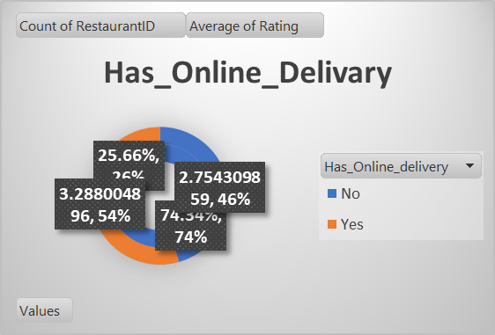

**Has_Online_Delivary**



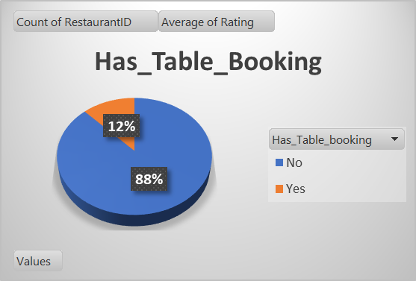

**Q7 Ref.Diargram**

**Q8.Should the team keep the rate of cuisines higher? Will that affect the feedback? According to our data are the rates of cuisines and ratings, correlated?**

* **Correlation of Rates and Ratings:-** Analyze the correlation of the average cost for two and the Ratings for each restaurants. This will make clear whether the higher cost are responsible for higher or lower ratings.
* **Approach:-**

In this question I used the pivot table to show the correlation of rating of cuisines and average cost of two is related or not, analyzing the below chart it can be clearly stated the rate of cuisines and ratings given are relatable to each other as rating increases the rate rate also increases.



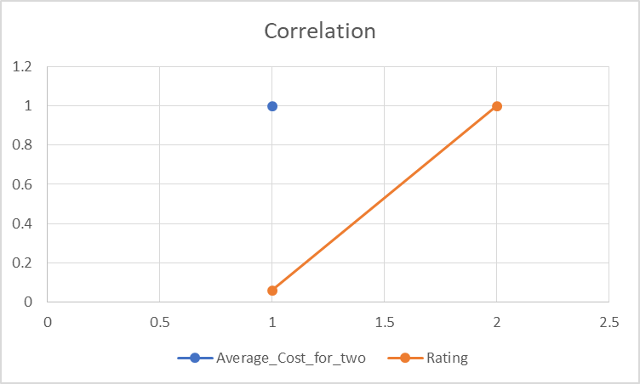

**Q8** **Ref. Chart**

**9) What is the distribution of the number of restaurants of different price ranges in all the countries?**

* To know the distribution of number of restaurants of different price range we can classify the restaurants in different class according to their price range and count of restaurant in each country

**Price Range Categories:**

* + **Low Price Range:** In this category the restaurants those are budget friendly and have less average cost for two.
  + **Mid Price Range:**  In this range the restaurants those have moderate price range and offer budget friendly dishes and quality are placed in this category.
  + **High Price Range:** This range mainly consist of restaurants that offer premium dining experience and astonishing feel.
  + **Luxury Range:** This restaurants give luxury dining experience with high price rate.
* **Approach:** 
  + We can categories the restaurants based on the price range column
  + Secondly count the restaurant in each category and for each country.
  + We can consider the following.

**Key Insights:**

* Countries with low budget restaurants generally denote the price sensitivity among the customers.
* Countries with high prices states that the customers generally focus on luxury rather than that of budget friendly dinning.

|  |  |  |  |  |  |
| --- | --- | --- | --- | --- | --- |
| **Count of RestaurantID** | **Column Labels** |  |  |  |  |
| **Row Labels** | **1** | **2** | **3** | **4** | **Grand Total** |
| Australia | 4 | 14 | 5 | 1 | 24 |
| Brazil | 2 | 7 | 16 | 35 | 60 |
| Canada |  | 3 |  | 1 | 4 |
| India | 4295 | 2858 | 1111 | 388 | 8652 |
| Indonesia |  | 1 | 20 |  | 21 |
| New Zealand | 3 | 4 | 17 | 16 | 40 |
| Philippines |  | 1 | 12 | 9 | 22 |
| Qatar |  | 1 | 5 | 14 | 20 |
| Singapore |  | 1 | 5 | 14 | 20 |
| South Africa |  | 4 | 17 | 39 | 60 |
| Sri Lanka |  | 6 | 11 | 3 | 20 |
| Turkey |  | 11 | 18 | 5 | 34 |
| United Arab Emirates |  | 9 | 29 | 22 | 60 |
| United Kingdom | 4 | 28 | 32 | 16 | 80 |
| United States of America | 136 | 165 | 110 | 23 | 434 |
| **Grand Total** | **4444** | **3113** | **1408** | **586** | **9551** |

**Q9. Ref Table (Price Range vs Count of Restaurants)**

**Q10 Explain your approach in brief for suggesting countries/cities in order to open new restaurants**

* **Market Analysis.**
  + To open restaurants in specific region analysis of existing restaurants with respect to the region and the city should be done and we should pick the areas where the competition is less.
  + Analysing the current expenditure according to the region will give us proper benchmark and proper market potential.
* **Quality Assurance.**
* Analysing the ratings provided will give us proper idea regarding the dining experience and it will also help us in deciding the voids to be fixed while opening the restaurants.
* **Location.**
* The area where restaurant is to be opened should be highly populated and we should prefer to urban areas as this are the areas where customer prefer the luxury than that of budget friendly dining.
* **Pricing.**
  + While planning the opening of a restaurant price of the dinning should be according to the region where restaurant is to be opened. Which required to be budget-friendly or high priced or luxury priced according to the region.